

NAME: MIAN MUHAMMAD AHMAD
CLASS: ADCS 3A
ROLL NO: 2500618
SUBJECT: FULL STACK WEB DEV

ADCS BATCH 2025 AIR UNIVERSITY ISLAMABAD

Assignment no 1-3
Part A: Class Task (15 Marks)
Interactive Grade Calculator

Part B Assignment no 1
1.Temperature Converter (4 marks)
Celcius
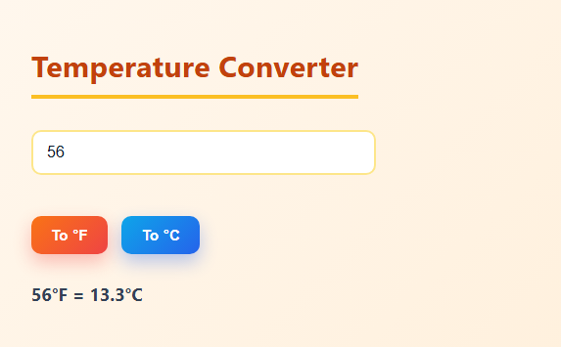
Fahrenheit
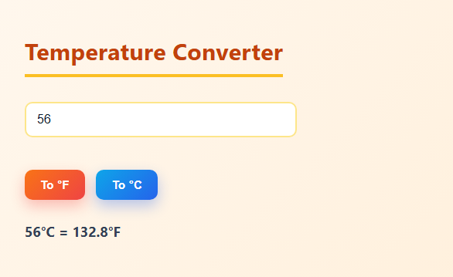

2.Fizz Buzz List (4 marks)
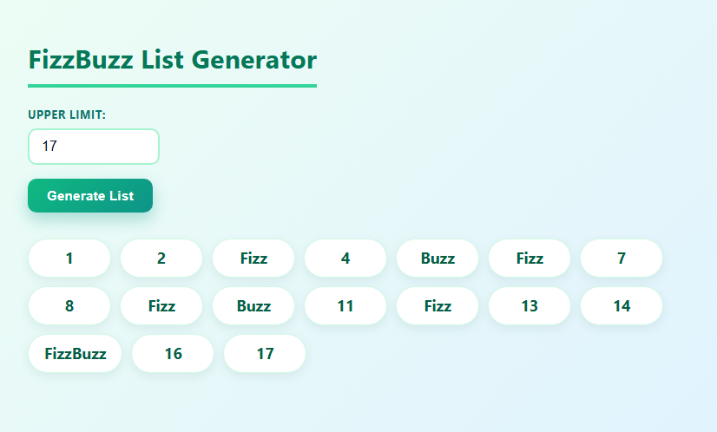
3.Student Records with Arrays & amp; Objects (4 marks)
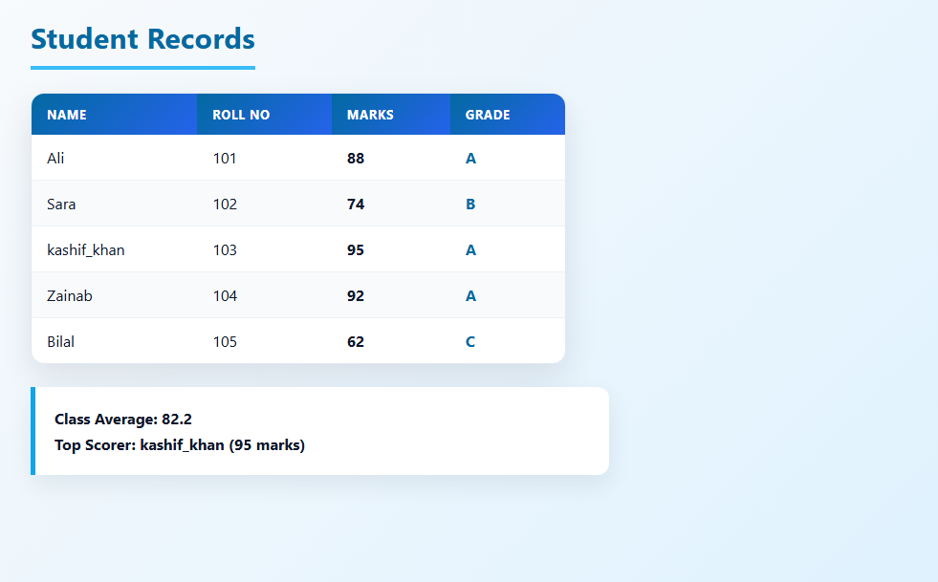

4. Click Counter with Theme Switcher (3 marks)
Dark Mode

Light Mode


Folder Structure
